Causal Discovery Algorithms: Types, Mechanisms, and Trade-offs
Constraint-Based Methods (CI Tests): These algorithms (e.g. PC, FCI) use conditional‐independence (CI) tests on the data to infer edges[1]. The PC algorithm first assumes causal sufficiency (no hidden confounders) and uses a sequence of CI tests to build an undirected graph skeleton, then orients edges by collider rules and propagation[1]. The Fast Causal Inference (FCI) algorithm extends PC to allow latent confounders and selection bias; it outputs a Partial Ancestral Graph (PAG) capturing all DAGs consistent with the observed independencies[1]. Constraint methods rely on the Causal Markov and Faithfulness assumptions: under these, they are asymptotically correct, but they only recover a Markov-equivalence class of DAGs (multiple DAGs can entail the same CI relations)[2].
- Pros: Broad applicability (no parametric model needed), asymptotically correct under assumptions[1]. Can handle high-dimensional data if CI tests are efficient. FCI can detect hidden confounders, increasing robustness.
- Cons: Performance depends on reliable CI tests and faithfulness; CI errors (especially with small samples or large conditioning sets) can mislead. These methods only identify an equivalence class, not a unique DAG[2]. They may leave many edges unoriented if the data lack discriminating patterns[2]. They assume faithfulness (which can fail) and typically cannot recover direction in simple two-variable cases[3]. Computationally, exploring all CI tests is expensive (complexity grows exponentially in worst case).
Score-Based Methods: Score-based algorithms assign each candidate graph a goodness-of-fit score (e.g. BIC, likelihood) and search for the graph maximizing it[4]. A classic example is Greedy Equivalence Search (GES), which starts from an empty graph and iteratively adds/deletes edges to improve the score[4]. Variants like GIES (Greedy Interventional Equivalence Search) incorporate known interventions for datasets with experiments.
- How they work: They define an objective (e.g. penalized log-likelihood) and perform a (usually greedy) search through DAG or equivalence-class space[4]. GES explicitly moves between Markov-equivalence classes, ensuring the output is a class maximizing the score.
- Pros: Can incorporate prior knowledge via the score function, and often performs better with finite samples than pure CI tests. Score functions can combine heterogeneous data (mixtures of Gaussian/discrete) easily.
- Cons: The search space of DAGs is super-exponential (NP-hard)[5], so most implementations use heuristics. GES may get trapped in local maxima and is not guaranteed to find the global optimum[5]. Like constraint-based methods, score-based search without further restrictions generally recovers only an equivalence class. Standard GES/GIES do not handle latent confounders by default. They also assume model correctness (e.g. linear Gaussian) for the score to be meaningful.
Functional/SEM-Based Methods: These assume explicit structural equations (functional causal models) and exploit distributional asymmetries. For example, LiNGAM assumes a linear, non-Gaussian SEM; by using Independent Component Analysis, it can identify a unique DAG (not just an equivalence class) under its assumptions[6]. More generally, Additive Noise Models (ANMs) and related methods assume each effect variable is a function of its parents plus noise (with the key property that the noise is independent of the parents). Because the noise-independence holds only in the true causal direction, fitting models in both directions and testing which yields independent residuals can orient edges[6].
- Pros: These methods can break equivalence: under correct model form they identify the full DAG. For instance, LiNGAM (linear, non-Gaussian) and ANM (nonlinear, additive-noise) provide algorithms that have unique solutions when their assumptions hold[6]. They can handle arbitrarily distributed data (nonlinear, nonparametric) as long as the functional form is appropriate.
- Cons: Rely on strong assumptions about the causal mechanisms. LiNGAM fails if data are nearly Gaussian or non-linear. ANMs assume no hidden confounders and a specific noise structure (additive). If the assumptions are violated (e.g. multivariate Gaussian noise, or unknown form of $f$), these methods may fail. They also generally assume causal sufficiency (no latent variables). In practice they can be computationally intensive (e.g. fitting neural nets for ANM) and may overfit without sufficient data.
Continuous Optimization Methods: A recent class reformulates structure learning as a continuous problem. NOTEARS is the flagship example: it treats the adjacency matrix $W$ as continuous weights and adds a smooth “acyclicity” constraint ${\rm tr}(e^{W \circ W}) - d = 0$[7]. In each iteration, the entire graph is updated by gradient-based optimization instead of greedy edge-by-edge search[7][8].
- How it works: One sets up a loss (e.g. least squares) plus the acyclicity penalty, and then uses augmented Lagrangian or similar solvers to minimize over $W$[7]. This allows incorporating L1 regularization for sparsity. Extensions of NOTEARS use neural nets in the structural equations, or different losses for discrete/Poisson data.
- Pros: The search is global (in principle), leveraging efficient numerical optimization[7]. It does not require hard combinatorial moves or CI tests. It naturally extends to differentiable models (e.g. deep nets) and various data types by changing the loss. It often scales relatively well to moderately large graphs because a single optimization handles all edges at once[7].
- Cons: NOTEARS (and its ilk) still solve a nonconvex problem: they can get stuck in local minima. They also inherit limitations of the assumed SEM (often linear Gaussian, though nonlinear versions exist). Crucially, they assume no latent confounders and rely on correct model specification. In practice these methods can be sensitive to hyperparameters and data scaling. For example, Kaiser & Sipos (2021) show that a simple rescaling of variables can flip NOTEARS’ output[9] (see image below). In other words, NOTEARS is not scale-invariant and may recover different DAGs under reparameterization[9].
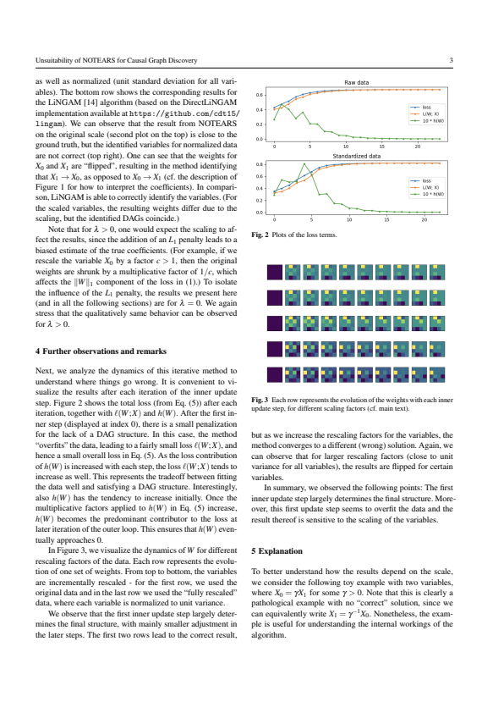
Figure: Example from Kaiser & Sipos (2021) showing NOTEARS’ scale-sensitivity. The top row shows the true graph $W$ and NOTEARS output on raw data, while the bottom row shows NOTEARS output after standardizing one variable (middle panels). The arrow orientation changes (X0→X3 reverses) for NOTEARS under scaling, whereas LiNGAM (bottom panels) consistently finds the correct X0→X3. This illustrates a weakness of NOTEARS: it may not identify the true causal direction if its assumptions (linearity, scale) are violated[9].
- Pros: Handles the whole graph jointly, with powerful optimizers. Easily incorporates regularization or prior knowledge in the loss. Extended versions (e.g. DAG-GNN, Graph MLPs) model nonlinearity.
- Cons: Sensitive to model mis-specification and scaling[9]. May be slower for very large graphs or require careful tuning (step sizes, regularizers). Like other methods, cannot on its own resolve confounders.
Deep-Learning-Based Methods: Beyond the continuous optimizers above, many neural-network approaches have been developed. These often model structural equations with flexible nets or use learned embeddings of graphs. For example, CGNN (Causal Generative Neural Network) models the joint distribution with a neural net and evaluates asymmetries[10]. DAG-GNN uses a graph-variational-autoencoder whose encoder and decoder are graph neural networks; it incorporates a continuous acyclicity constraint in the latent space[11]. Other methods include using permutation-learning, reinforcement learning, or attention mechanisms to search graph structures.
- Pros: These methods can capture very complex nonlinear relationships. They often scale well with data via minibatch training and GPU acceleration. DAG-GNN, for example, naturally handles discrete or mixed data and has shown better recovery on highly nonlinear synthetic data[11]. CGNN makes no assumption about the absence of confounders[10] and can be more flexible in data distribution.
- Cons: They tend to be data‐hungry and computationally intensive. Results can be hard to interpret or diagnose (black-box nature). Generally there are no strong theoretical guarantees of correctness; they still suffer from the fundamental identifiability issues unless extra assumptions or interventions are given. Model training can be unstable, and performance depends on architecture/hyperparameter choices.
Time-Series and Temporal Methods: Causal discovery in time series exploits time ordering. The classic technique is Granger causality: one time series Granger-causes another if past values of the first help predict the second beyond what the second’s own past can predict[12]. In practice this often means fitting a vector autoregression and testing for nonzero lagged coefficients. Extensions include nonlinear Granger methods (e.g. Transfer Entropy, neural-network Granger) to capture more complex dynamics[13]. Constraint-based and continuous methods have analogues for time series (e.g. PCMCI or temporal SEMs), which test for lagged conditional independencies.
- Pros: Temporal order can greatly reduce equivalence (instantaneous feedback still complicates things). Many well-studied tools exist in econometrics and neuroscience.
- Cons: Granger-like methods typically assume stationarity and often linearity[12][14]. Hidden common drivers (unobserved time series) and measurement delays can violate model assumptions. Nonstationarity or irregular sampling further complicate inference. Overall, causal discovery in time series often requires careful preprocessing and remains challenging in the presence of confounders or nonlinearity.
Interventional and Mixed-Data Methods: When data from multiple experimental conditions are available, causal discovery can be enhanced. Algorithms like GIES (an extension of GES) search over interventional equivalence classes, exploiting known interventions. Constraint-based methods have “do-calculus” analogues (e.g. conditioning on intervention targets) to orient edges. Hybrid approaches (e.g. combining score and constraint) also exist. If one has partial knowledge of which variables were intervened on, many ambiguities in observational graphs can be resolved.
- Pros: Interventional data can distinguish among Markov-equivalent DAGs; in the extreme of fully randomized experiments one can identify the causal graph. Specialized algorithms converge faster.
- Cons: In practice we often lack fully random interventions (ethical or logistical constraints). Algorithms for mixed observational/interventional data (e.g. joint-IDA, Invariant Causal Prediction) still need assumptions like no hidden changes in mechanism. Many classical algorithms do not directly incorporate such data without modification.

Benchmarks and Example Datasets
Researchers test causal discovery methods on both real and synthetic data. A prominent semi-simulated benchmark is the IHDP (Infant Health and Development Program) dataset, originally an RCT study with a simulated outcome, commonly used for treatment-effect evaluation[15]. Other real datasets with assumed causal structures include Sachs’s protein-signaling network data[16], and UCI datasets like Abalone and Boston Housing where researchers impose plausible causal graphs[16]. The Tübingen Cause-Effect Pairs collection provides ~108 two-variable datasets (from diverse domains) with known causal direction[17]. Simulated DAGs (randomly generated graphs with parametric edges) are also widely used, as are challenge datasets (e.g. ACIC competitions). In all cases the true graph (or effect of interventions) is known so algorithms can be evaluated. These benchmarks help compare methods under varying conditions (linear vs nonlinear, with/without confounders, etc.)[15][17].

Why No Perfect Algorithm Exists
- Identifiability Limits: From purely observational data, many different DAGs can imply the same statistical independencies. In general one can only recover a Markov equivalence class, not a unique causal graph[2]. Without additional assumptions or experiments, edges that are “unshielded colliders” or part of certain patterns cannot be oriented.
- Hidden Confounders: If latent common causes exist, no algorithm can infer the true graph of only the measured variables without assumptions. Constraint-based methods like FCI can detect some latent effects, but they still output a partial graph (PAG) and can miss confounders. In practice, unmeasured confounders violate the faithfulness assumption and lead to wrong or undetermined edges[1][3].
- Strong Assumptions Required: Every method requires conditions (acyclicity, faithfulness, model form, etc.). Faithfulness (no exact cancellations of effects) is a strong assumption that may need large samples to hold[3]. If the true data-generating process falls outside an algorithm’s assumptions (e.g. nonlinear when using a linear SEM, or Gaussian noise for LiNGAM), the output can be incorrect or ambiguous. As noted by Glymour et al., “faithfulness is a strong assumption” and without it the recovered structure can be non-unique[3].
- Statistical and Computational Limits: In finite samples, CI tests and score estimates are noisy. Spurious correlations, limited sample size, and high-dimensional settings can cause errors. Moreover, DAG search is NP-hard in general[5], so practical algorithms use heuristics. There is no free lunch: methods that work quickly may sacrifice exhaustiveness, and exact approaches (e.g. exhaustive search) are intractable beyond a few variables.
- Sensitivity to Preprocessing: Many algorithms can be altered by simple reparameterizations. For instance, Kaiser & Sipos show that NOTEARS (and similar continuous methods) can output different DAGs under scaling of variables[9]. In general, how data are normalized or discretized can change conditional independence patterns, causing any algorithm to fail.
- Unobserved Data Issues: Measurement error, missing data, or selection bias can violate basic assumptions and mislead any discovery method. All algorithms typically assume the data accurately reflect the underlying causal processes.
- The “No Miracle” Barrier: Fundamentally, without interventions or very strong domain knowledge, pure observational data cannot prove causation. Methods can exploit asymmetries or nonlinearities, but in many cases (e.g. linear Gaussian models) cause-effect direction is inherently unidentifiable without something extra[3].
Because of all these factors, no single causal discovery algorithm works in every setting. The best choice depends on data type, assumed model, and what limitations (e.g. latent confounders) are acceptable. In practice one often compares multiple methods or incorporates background knowledge to triangulate plausible causal structures.
Sources: Algorithm descriptions and comparisons are drawn from standard reviews and papers[1][6][3]. Examples of deep-learning methods and their performance are given in recent literature[10][11]. Benchmark datasets are documented by the causal inference community[15][17]. The impossibility results and assumptions (e.g. faithfulness, Markov equivalence) are well known in the causality literature[1][3][9].

[1] [2] [3] [4] [6] Review of Causal Discovery Methods Based on Graphical Models - PMC
https://pmc.ncbi.nlm.nih.gov/articles/PMC6558187/
[5] [7] [8] Learning DAGs with Continuous Optimization – Machine Learning Blog | ML@CMU | Carnegie Mellon University
https://blog.ml.cmu.edu/2020/04/10/learning-dags-with-continuous-optimization/
[9] causalens.com
http://causalens.com/wp-content/uploads/2025/05/NOTEARS.pdf
[10] [1711.08936] Causal Generative Neural Networks
https://arxiv.org/abs/1711.08936
[11] DAG-GNN: DAG Structure Learning with Graph Neural Networks
https://proceedings.mlr.press/v97/yu19a.html
[12] [13] [14] Time series causal relationships discovery through feature importance and ensemble models | Scientific Reports
https://www.nature.com/articles/s41598-023-37929-w?error=cookies_not_supported&code=06d15f76-ccd0-4624-a2ca-cf857c1de53b
[15] [16] CMU-CLeaR Group | Benchmarks
https://www.cmu.edu/dietrich/causality/projects/causal_learn_benchmarks/
[17] Cause-Effect Pairs from MPI Tübingen
https://zenodo.org/records/14861446

